**CS390S Assignment 5 (10 points + bonus)**

**Quality Metric**

**Requirements:**

**Measure the image quality with different distortions using different quality metrics we have learned and your own quality metric.**

Select one of your own images with an object at the center part, use it as your original image. Generate two images with different distortions using the original image. The first distortion image has a distortion on salient area, the second distortion image has a distortion on the non-salient area. (You could use any image editing tool or your own program to generate the image with distortions.)

For example:

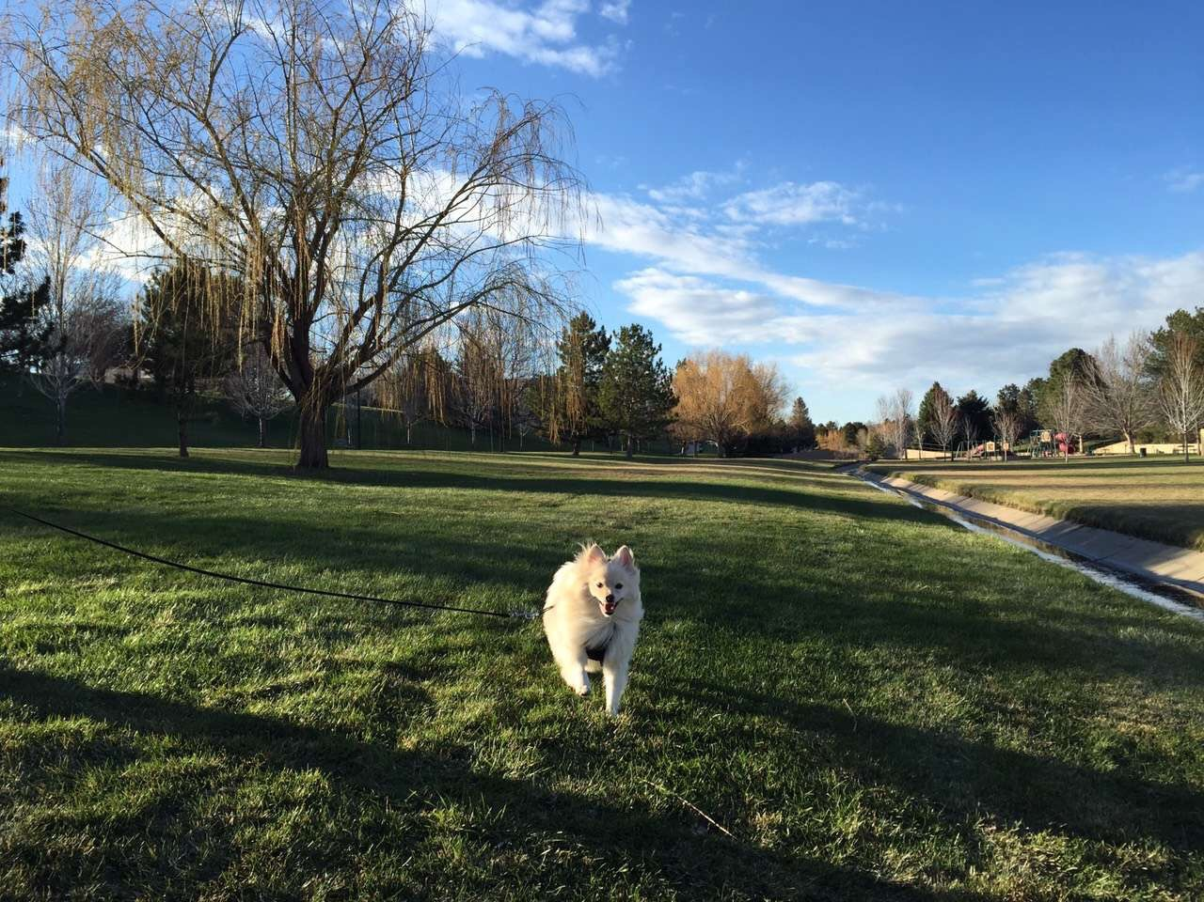

original image



distortion 1 distortion 2

Measure the quality of the two distortion images using MSE, PSNR, SSIM and your own quality metric.

Design your intelligent quality metric to measure the quality of the two images with distortions using saliency map.

Clearly describe your own quality metric design in the report. Explain the usage of your own quality metric in the report as well, such as quality measurement value of 1 means perfect quality and quality measurement value of 0 means worst quality.

Show the original image, the distortion images, the saliency map and the measurement values:

MSE_1 and MSE_2

PSNR_1 and PSNR_2

SSIM_1 an SSIM_2

in the report.

**Reference:**

Hint and reference materials:

1)Saliency map:

Matlab users without machine learning toolbox could use saliency tool2 See **Reference2.**

Matlab users with machine learning toolbox could use GBVS saliency tool from

<http://www.vision.caltech.edu/~harel/share/gbvs.php>

(see slide13 for more details)

Install GBVS, set your work path try the demo code using following instructions

<http://www.vision.caltech.edu/~harel/share/gbvs/readme.txt>

If you would like to save the maps, matlab command “save maps.mat” or “load maps.mat” can be used.

Python users could try OpenCV tool:

saliency_obj = cv2.saliency.StaticSaliencySpectralResidual_create()

success, saliency_float = saliency_obj.computeSaliency(im)

Resize the saliency map to original image size. Normalization might be needed as well depends on your metric design.

Try your own dog or human images with some object in a relatively clear background.

Show your original image and the corresponding saliency map in your report.

2)matlab users check PSNR, MSE and SSIM demo code from blackboard/content/Code&Images.

Python users check PSNR, MSE and SSIM reference code from blackboard/content/assignments/assignment5.

**What to submit:**

1. **Your report “Firstname_Lastname_HW5.docx/doc” or “Firstname_Lastname_HW5.pdf”**

In your report, please always include the input and output images and a brief discussion of your design or explanation of your code.

1. **A compressed “.zip” file** (**NO** “.rar” files accepted) including all the source code files and source images, output images, “read me” file or other support files to run your code.

**Reference2:**

Saliency tool2

1. Please download the “saliency toolbox2” from blackboard

Or follow the <http://www.saliencytoolbox.net/download.html> link to download the toolbox from the website.

(Students who have machine learning toolbox installed in Matlab could use the GBVS toolbox. Students who do not have machine learning toolbox installed should use the above SaliencyToolbox.)

2. Change Matlab working path to the folder of your SaliencyToolbox.

3.Test the saliency generation for the demo image balloons.png by the command

*guiSaliency('img/balloons.png');*

1. Click the “start” button on the GUI

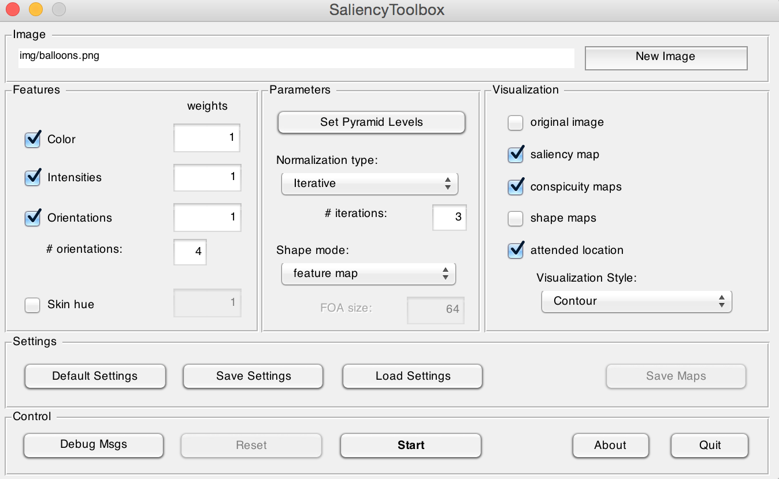

1. Save the saliency maps generated (the maps.mat file) to a folder by clicking on “save map”.



1. Whenever you would like to use the maps, you could load the mat file by command “load maps.mat” or change the working path to the path of that file and double click that file to load it.

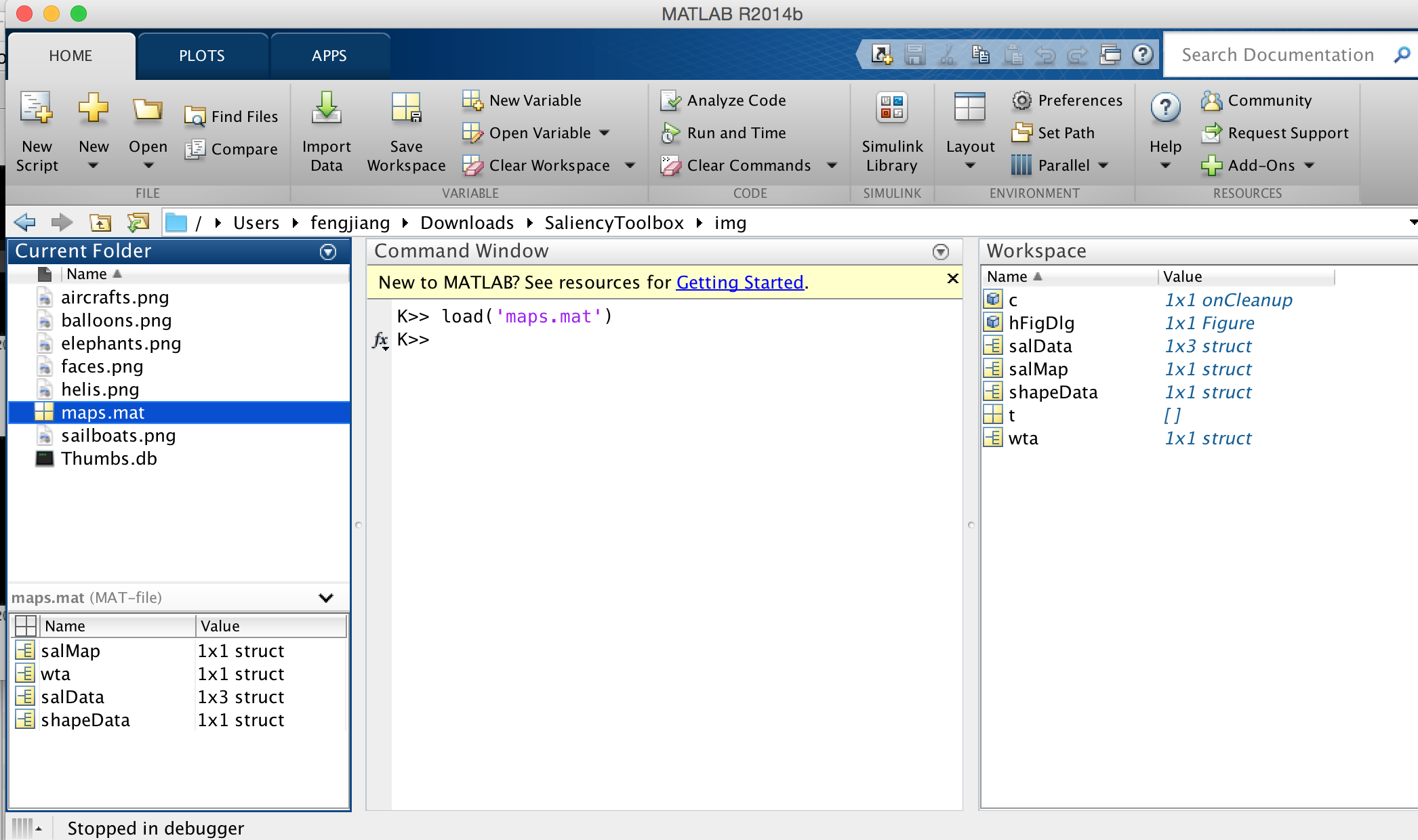

1. The saliency map generated

The saliency map matrix is stored in the struct element “salMap.data”. You could try to show this map by *figure, imshow(salMap.data);*